|  |
| --- |
| TS057 - TC083_Process Termination of Electric Service Case to Application Closed |

|  |
| --- |
| TC120_Termination of Service via CXE Apply_Contractor; CAN with Multiple SIN |

|  |
| --- |
| Step 1 - Go tohttps://fuat-meralco.cs73.force.com/customers/s/cxe-apply |
| Service Application page should be displayed |

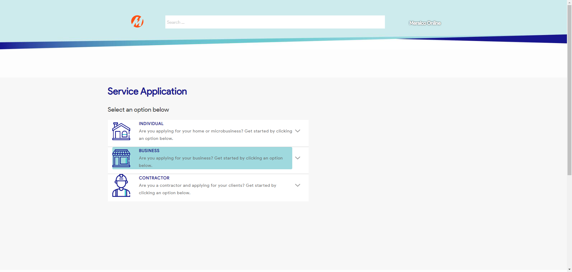

|  |
| --- |
| Step 2 - Click on Contractor |
| The following should be displayed under Contractor - Start Service - Modify Service - Reactivate Service - Stop Service |

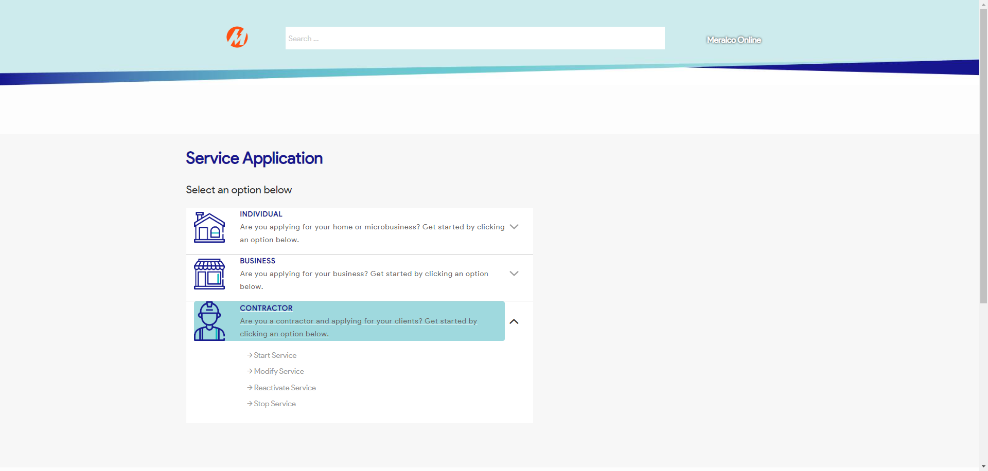

|  |
| --- |
| Step 3 - Select Stop Service |
| Stop a Service page should be displayed |

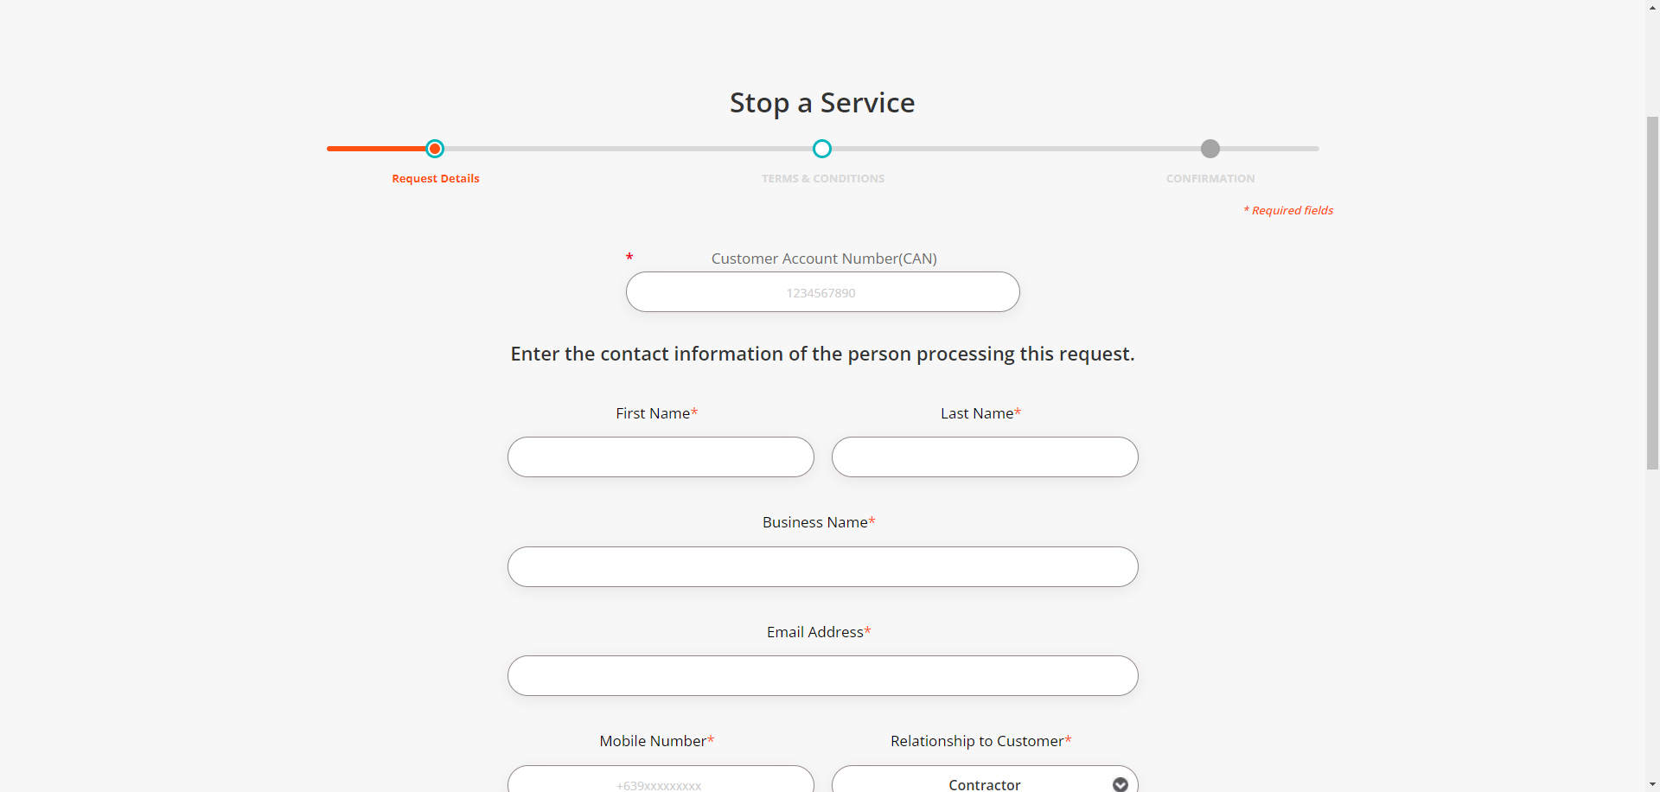

|  |
| --- |
| Step 4 - Validate if CAN field is visible and enabled |
| CAN field should be visible and enabled |



|  |
| --- |
| Step 5 - Populate Customer Account Number field |
| Customer Account Number field should be populated; Service ID Number field should be displayed |

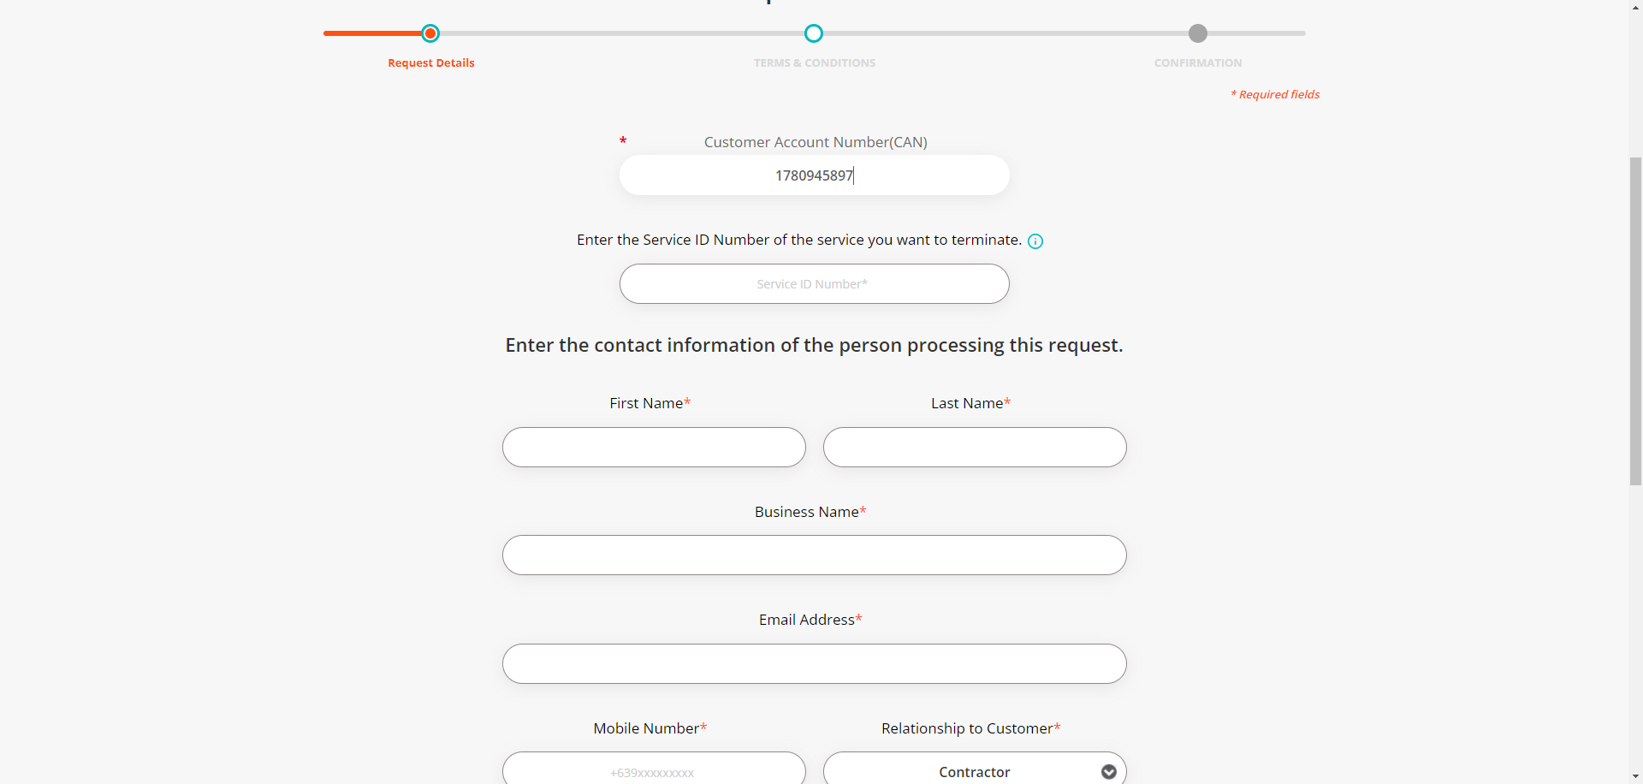

|  |
| --- |
| Step 6 - Populate Service ID Number |
| Service ID Number field should be populated |

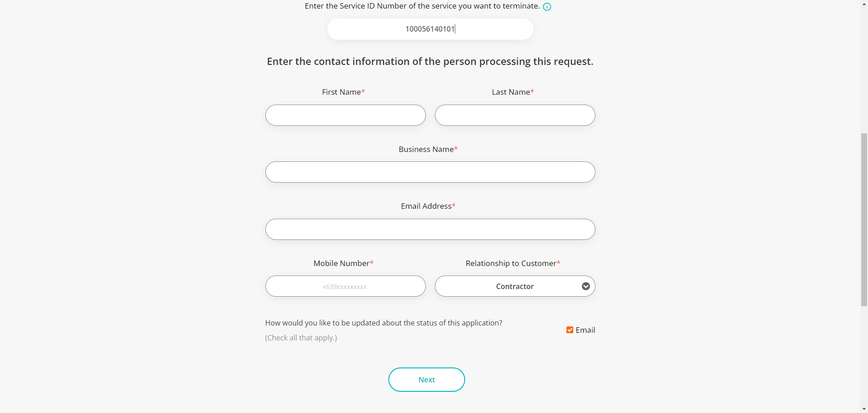

|  |
| --- |
| Step 7 - Populate the following: First Name* Last Name* Business Name* Email Address* Mobile Number* Relationship to Customer* Notification indicator > Click Next |
| Fields should be populated; Terms and Conditions tab should be displayed |

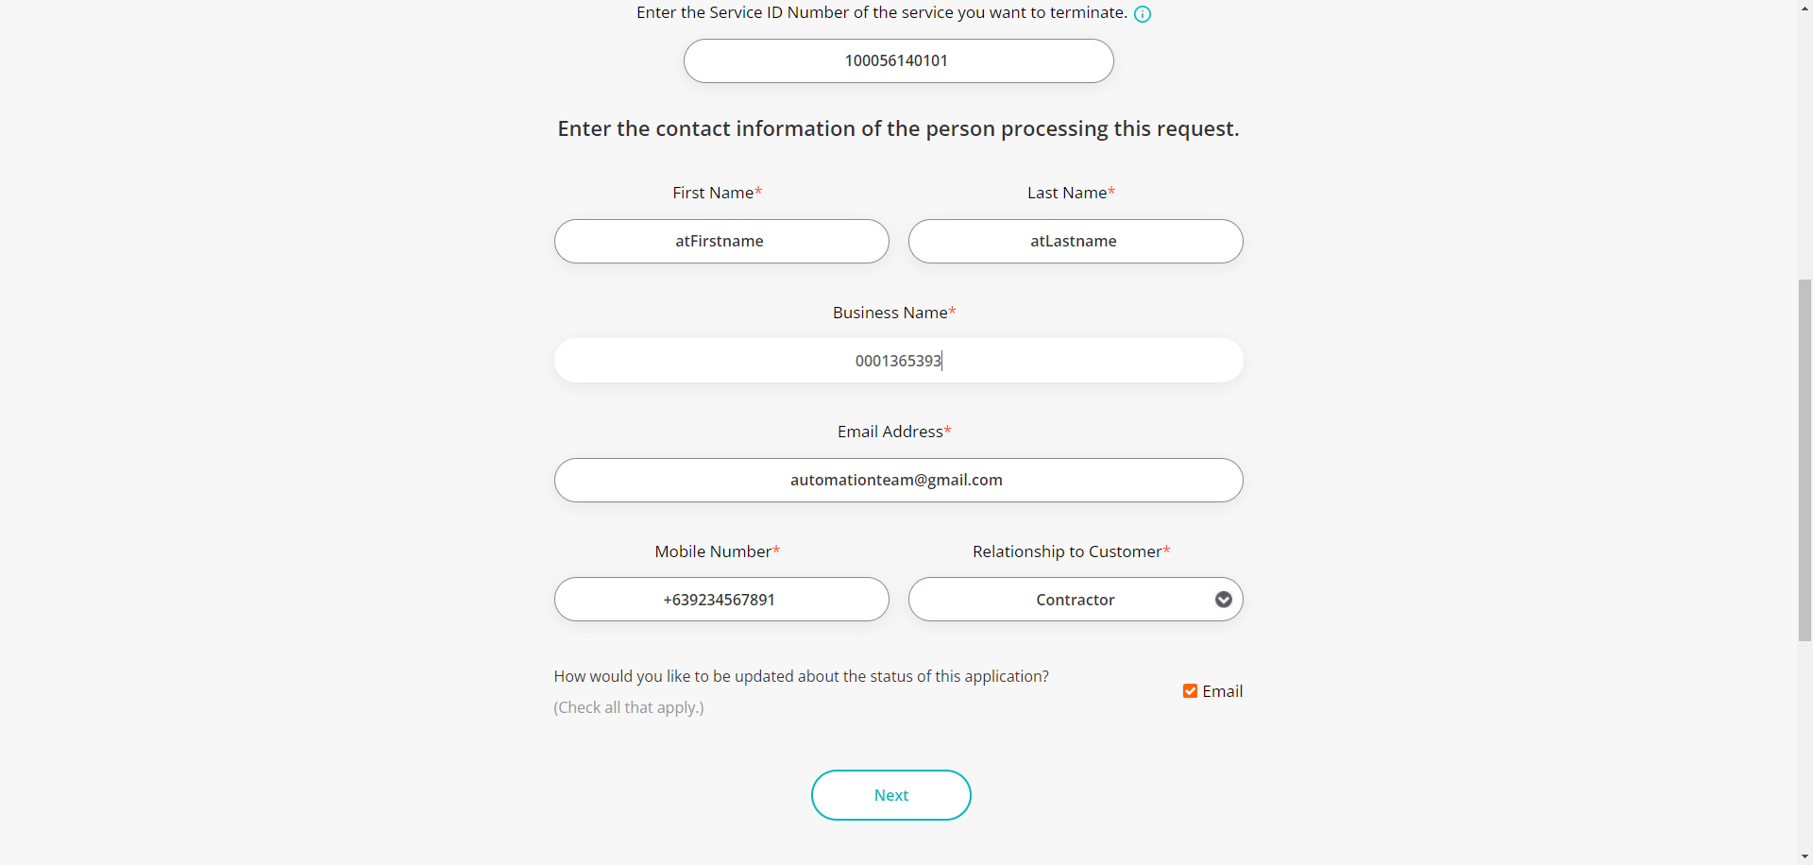

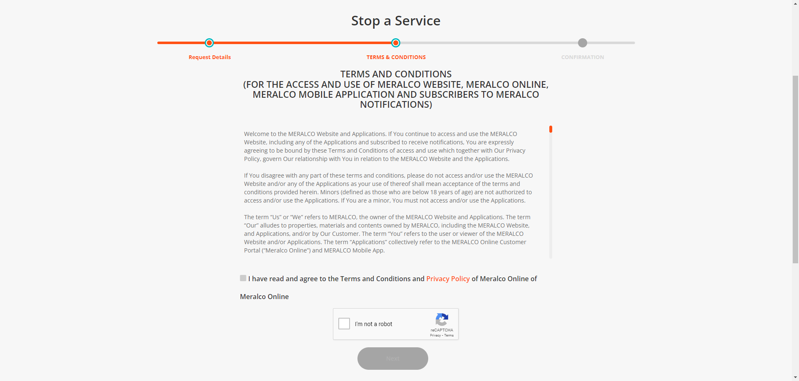

|  |
| --- |
| Step 8 - Tick on Terms & Conditions and Privacy Policy agreement |
| Submit button should be enabled |

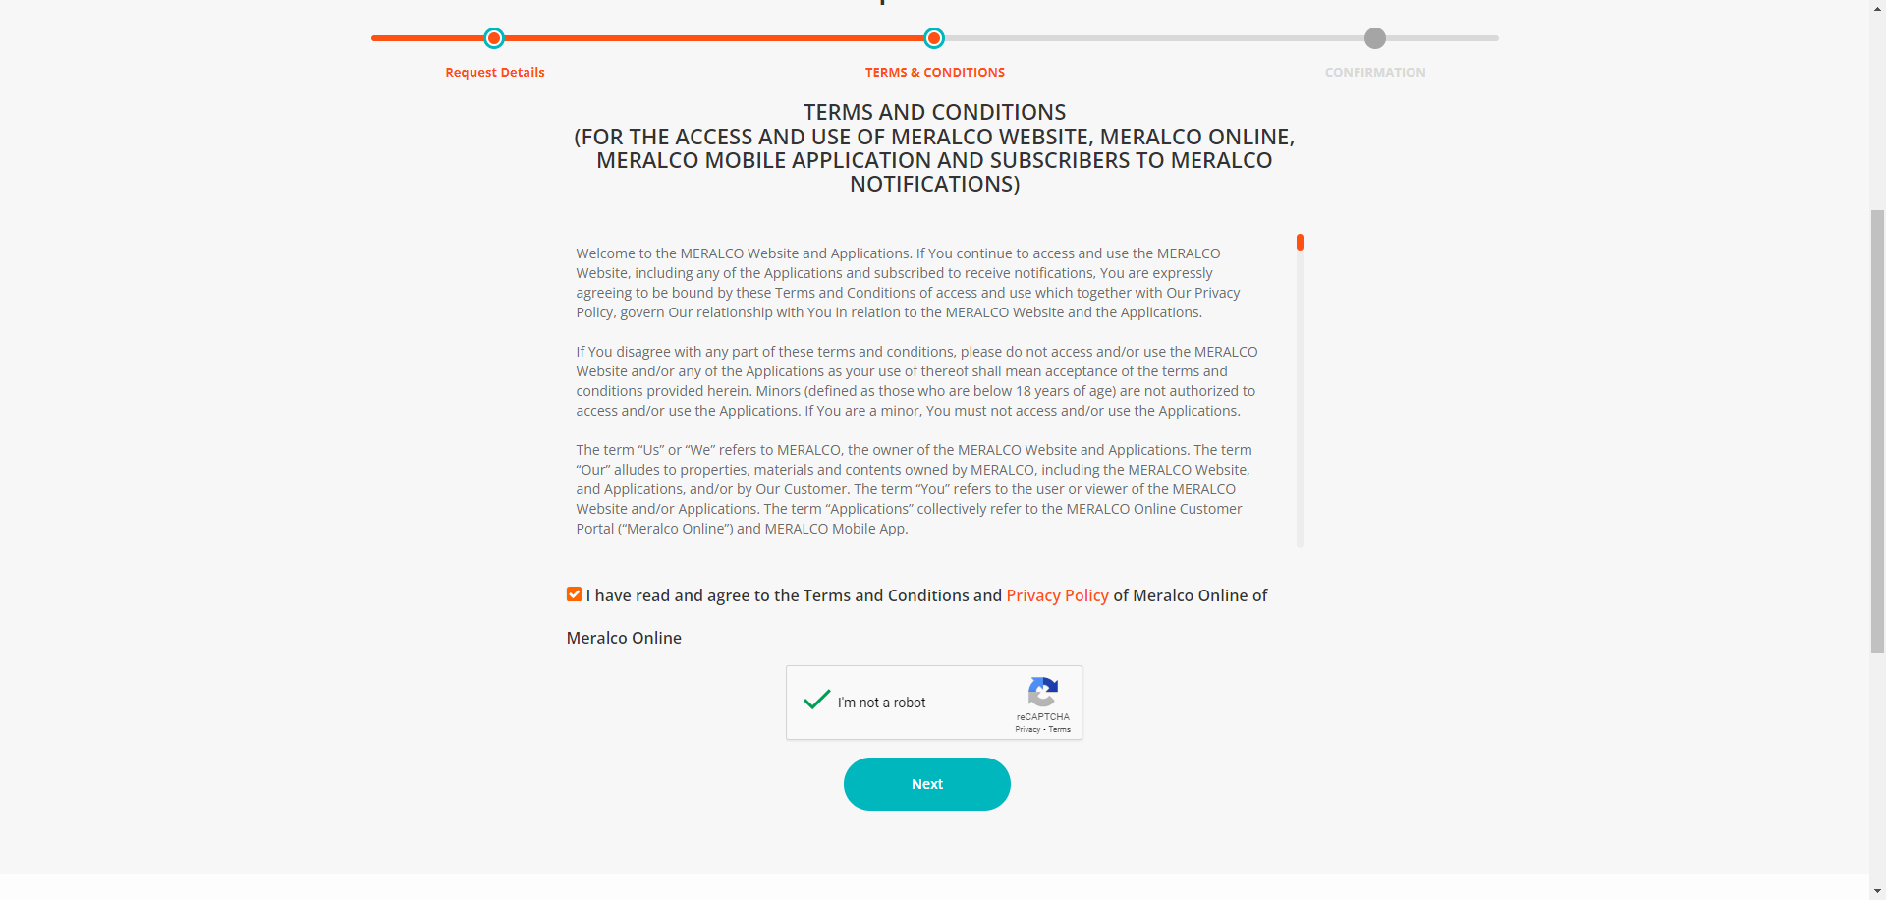

|  |
| --- |
| Step 9 - Click Next |
| Confirmation tab should be displayed. Case # should be generated. |

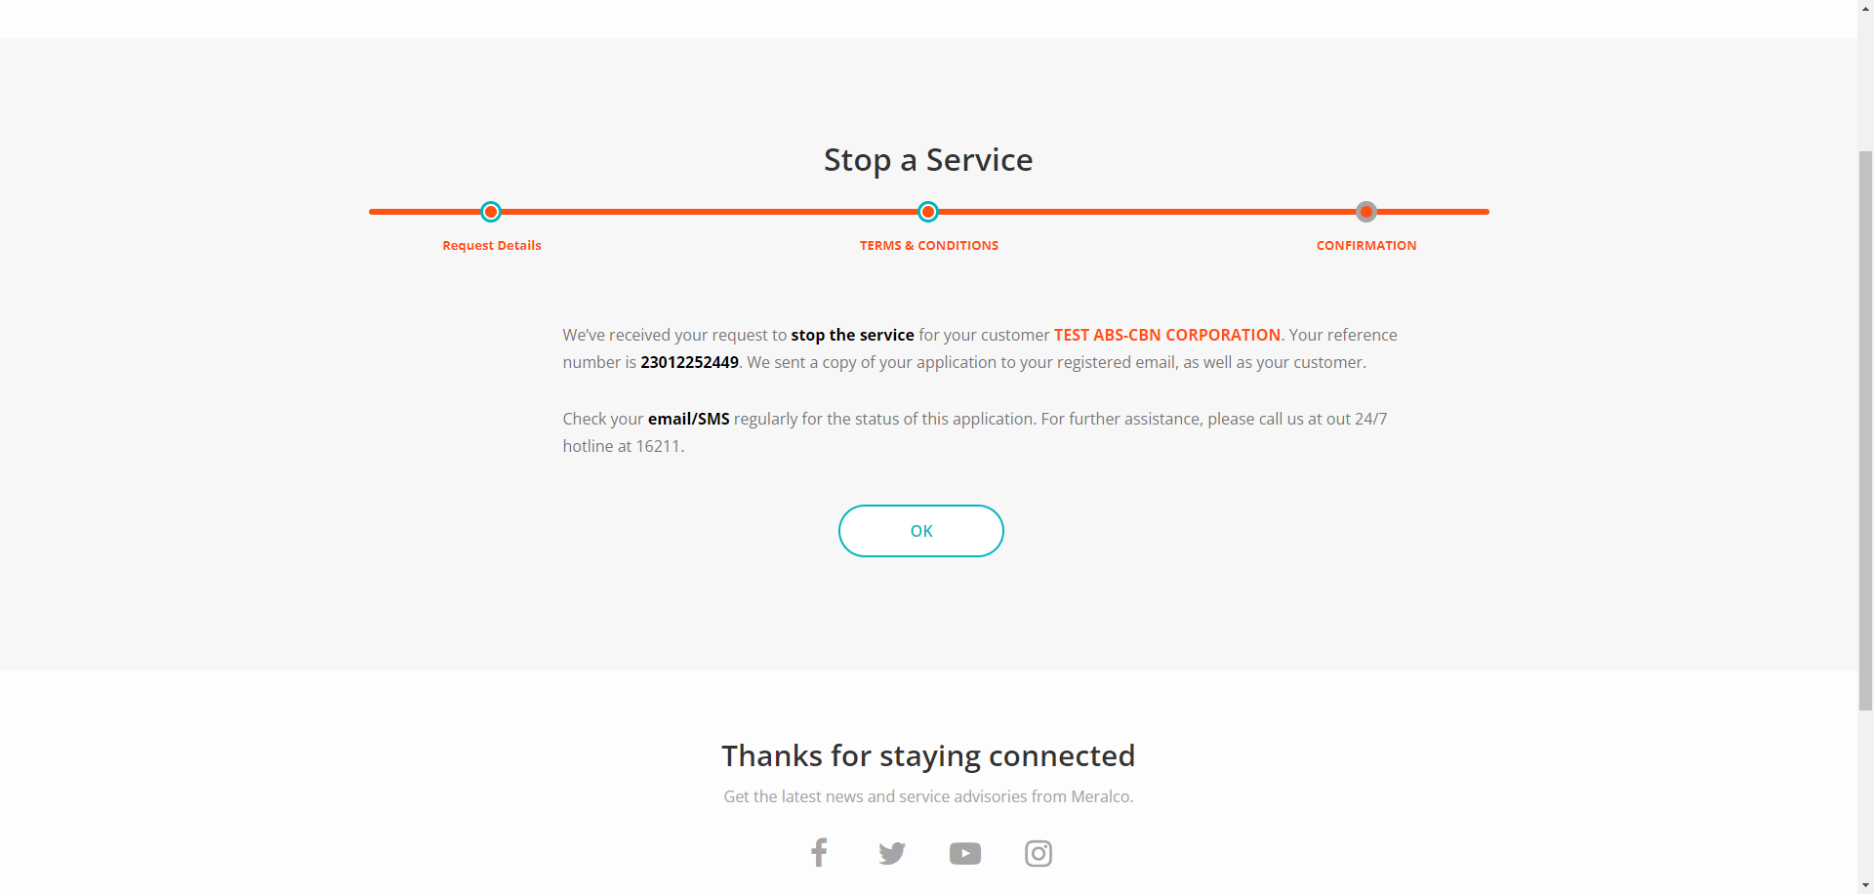



Passed